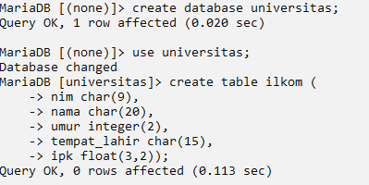

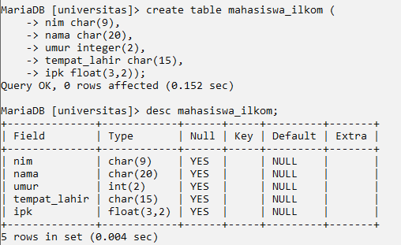

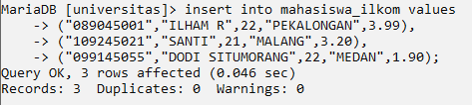

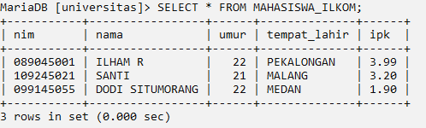





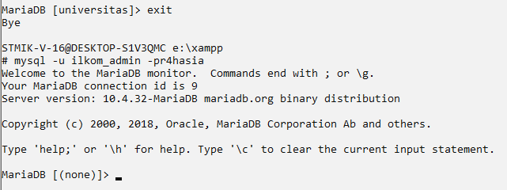  


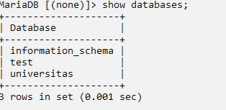

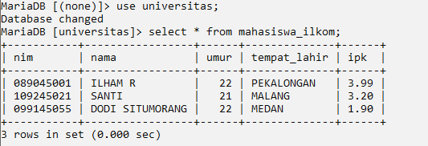

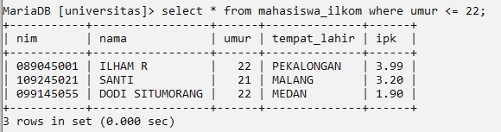

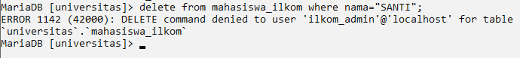

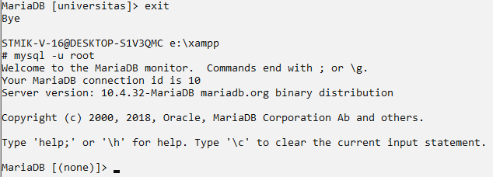

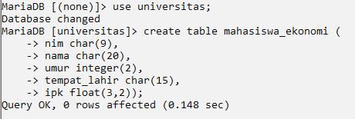

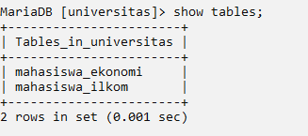

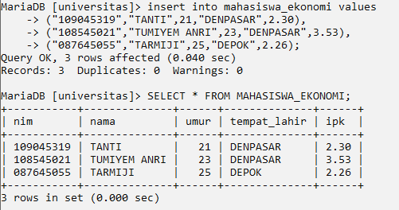





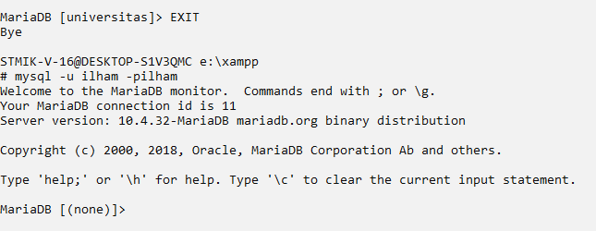

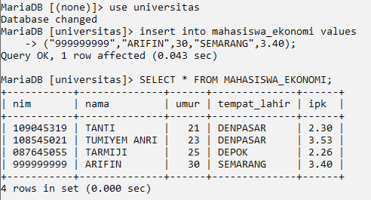

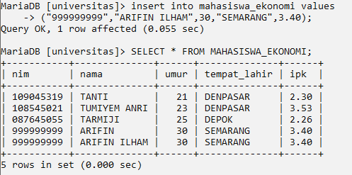

**KUIS**

**Buatlah di root (mysql -u root)**

USER : Jurusan

PASSWORD : Jurusan_Admin

Database : Universitas

Tabel : Semua

Perintah : Insert, update, select, delete

Masuk ke user jurusan, LALU

Tabel mahasiswa_ilkom ( select * from mahasiswa_ilkom);

delete from mahasiswa_ilkom where nama="SANTI";

SELECT * FROM MAHASISWA_ILKOM

UPDATE TABEL MAHASISWA EKONOMI ( update mahasiwa_ekonomi set ipk=3.92 umur=24 where nim="108545021";

